**1. JUnit_Basic Testing Exercises**

**Exercise 1: Setting Up Junit**

**Scenerio 1 and 2**

**Pom.xml**

<?xml version="1.0" encoding="UTF-8"?>  
<project xmlns="http://maven.apache.org/POM/4.0.0"  
 xmlns:xsi="http://www.w3.org/2001/XMLSchema-instance"  
 xsi:schemaLocation="http://maven.apache.org/POM/4.0.0  
 http://maven.apache.org/xsd/maven-4.0.0.xsd">  
  
 <modelVersion>4.0.0</modelVersion>  
  
 <groupId>com.example</groupId>  
 <artifactId>jdemo</artifactId>  
 <version>1.0-SNAPSHOT</version>  
  
 <properties>  
 <maven.compiler.source>24</maven.compiler.source>  
 <maven.compiler.target>24</maven.compiler.target>  
 <project.build.sourceEncoding>UTF-8</project.build.sourceEncoding>  
 </properties>  
  
 <dependencies>  
 <dependency>  
 <groupId>junit</groupId>  
 <artifactId>junit</artifactId>  
 <version>4.13.2</version>  
 <scope>test</scope>  
 </dependency>  
 </dependencies>  
 </project>

3.

**Calculator.java**

package com.example;  
  
public class Calculator {  
 public int add(int a, int b) {  
 return a + b;  
 }  
}

**CalculatorTest.java**

package com.example;  
import org.junit.Test;  
import static org.junit.Assert.*;  
public class CalculatorTest {  
 public void add_should_sum_two_numbers() {  
 Calculator calc = new Calculator();  
 int result = calc.add(2, 3);  
 *assertEquals*(5, result);  
 }  
}

OUTPUT:

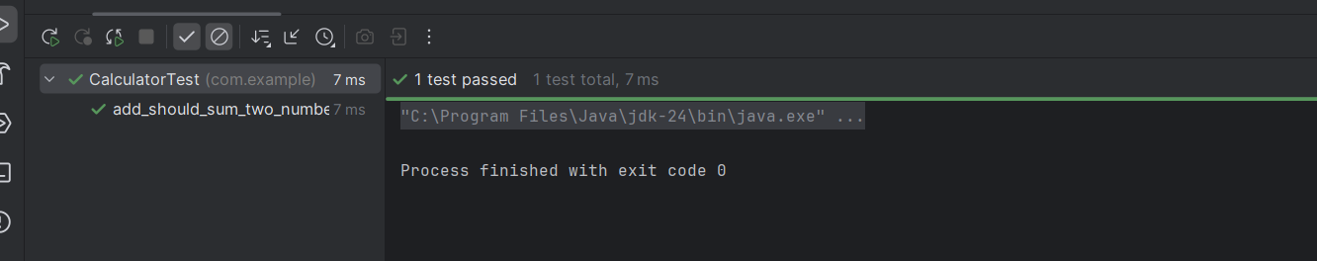

**Exercise 3: Assertions in JUnit**

**AssertionsTest.java**

package com.example;  
import org.junit.Test;  
import static org.junit.Assert.*;  
public class AssertionsTest {  
 @Test  
 public void testAssertions() {  
 *assertEquals*(5, 2 + 3);   
 *assertTrue*(5 > 3);

*assertFalse*(5 < 3);  
Object obj1 = null;  
 *assertNull*(obj1);  
Object obj2 = new Object();  
 *assertNotNull*(obj2);  
}

output:

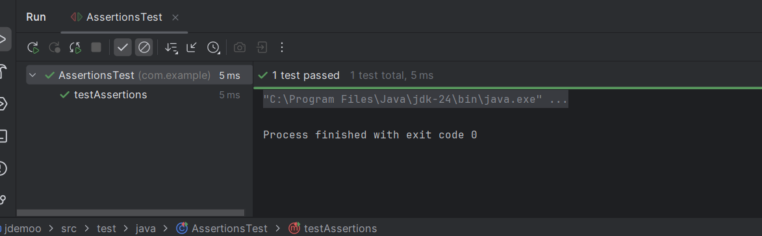

**Exercise 4: Arrange-Act-Assert (AAA) Pattern, Test Fixtures, Setup and Teardown Methods in Junit**

**MathHelper.java**

package com.example;  
public class MathHelper {  
 public int multiply(int a, int b) {  
 return a * b;  
 }  
public int divide(int a, int b) {  
 return a / b;  
 }  
}

**MathHelperTest.java**

package com.example;  
import org.junit.After;  
import org.junit.Before;  
import org.junit.Test;  
import static org.junit.Assert.*;  
public class MathHelperTest {

private MathHelper math;  
 @Before  
 public void setUp() {  
 System.*out*.println("Setting up...");  
 math = new MathHelper();  
 }  
 @After  
 public void tearDown() {  
 System.*out*.println("Cleaning up...");  
 math = null;  
 }  
  
 @Test  
 public void multiply_twoPositiveNumbers_returnsProduct() {  
   
 int a = 4, b = 5;  
 int result = math.multiply(a, b);  
 *assertEquals*(20, result);  
 }  
  
 @Test  
 public void divide_twoNumbers_returnsQuotient() {  
 int a = 10, b = 2;  
 int result = math.divide(a, b);  
 *assertEquals*(5, result);  
 }  
}

**OUTPUT:**

